DATA ANALYSIS INTERNSHIP – DAY 22 REPORT
Organization: Top Tech Developers
Task Name: E-Commerce Sales Analysis with Data Transformation in Power BI (Home Task)

Introduction
Microsoft Power BI is a powerful business intelligence and data visualization tool used to transform raw data into meaningful insights through interactive dashboards and reports.
On Day 22, an E-Commerce Sales Analysis Dashboard was created using Power BI. The project focused on analyzing online shopping sales data, customer behavior, product performance, payment trends, and delivery status. Data transformation techniques were also applied using conditional columns to improve business analysis and reporting.

1. Objective
The primary objective of this project was to analyze online shopping sales data and create an interactive dashboard that helps in understanding:
- Customer purchasing behavior
- Product performance
- Payment method trends
- Sales distribution
- Delivery efficiency
- Profit classification
The dashboard enables businesses to make data-driven decisions through visual analysis.

2. Dataset Description
The dataset represents an online shopping system and contains the following fields:
Column Name | Description
Order_ID | Unique order identification number
Customer_Name | Name of the customer
Gender | Customer gender
City | Customer location
Product_Category | Product category
Product_Name | Product purchased
Order_Date | Date of order
Payment_Method | Payment mode used
Quantity | Number of products ordered
Unit_Price | Price per product
Total_Amount | Total order value
Delivery_Status | Delivery outcome
The dataset was imported into Microsoft Power BI and enhanced through data transformation techniques.

3. Data Transformation
To improve business analysis, new calculated columns were created using conditional logic in Power BI.
1. Profit Category
The Total Amount column was classified into different profit levels.
Profit Range | Category
Less than 2000 | LOW
2000 – 10000 | MEDIUM
Greater than 10000 | HIGH
Purpose
- Categorizes sales performance
- Identifies high-value transactions
- Simplifies profit analysis

2. Order Priority
Orders were categorized based on business requirements.
Categories
- High Priority
- Moderate Priority
- Low Priority
Purpose
- Identifies urgent orders
- Improves order management
- Helps prioritize customer requests

3. Customer Segment
Customers were grouped according to their spending behavior.
Spending Range | Customer Segment
Less than 2000 | Low Spender
2000 – 10000 | Medium Spender
Greater than 10000 | High Spender
Purpose
- Understands customer purchasing patterns
- Identifies premium customers
- Supports customer segmentation analysis

4. Dashboard Visualizations Created
After transformation, multiple visualizations were created to analyze the data effectively.

1. Bar Chart – Sum of Total Amount by Customer Name
Purpose
This chart displays total spending by each customer.
Analysis Performed
- Top spending customers
- Medium spending customers
- Low spending customers
Business Use
- Identifies high-value customers
- Supports customer retention strategies
- Helps target premium customers
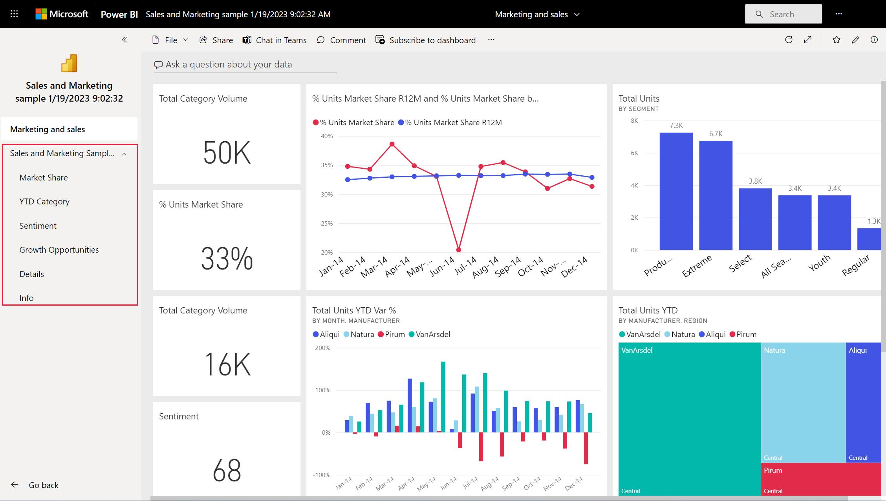
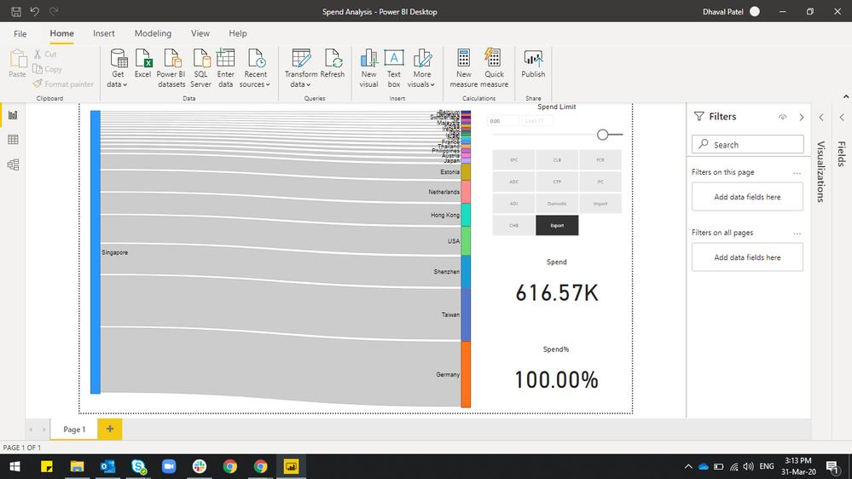
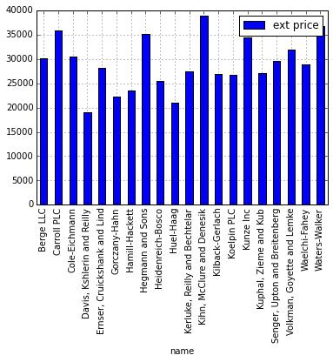


2. Pie Chart – Payment Method / Product Category / Product Name
Purpose
This chart shows category-wise distribution within the dataset.
Analysis Performed
- Most used payment methods
- Best-selling product categories
- Product popularity distribution
Payment Methods Analyzed
- UPI
- Card
- Cash on Delivery (COD)
Business Use
- Studies customer preferences
- Identifies popular products
- Supports marketing decisions

3. Card Visual – Count of Profit Category
Purpose
Displays the total count of profit classifications.
Categories Included
- LOW
- MEDIUM
- HIGH
Business Use
- Quick overview of sales performance
- Summarizes profit distribution
- Supports revenue analysis

4. Map Visual – Order Distribution Analysis
Purpose
Displays geographical distribution of orders using location data.
Analysis Performed
- Order locations
- City-wise sales distribution
- Regional customer activity
Business Use
- Tracks location-based sales performance
- Identifies high-demand regions
- Supports regional business expansion
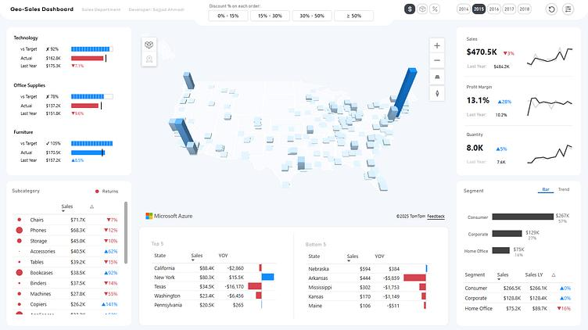
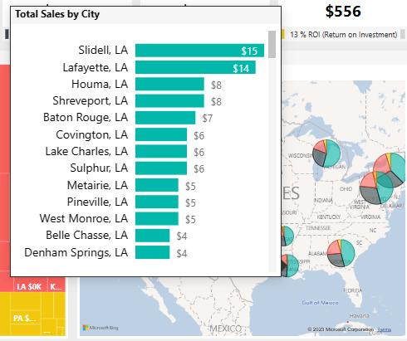
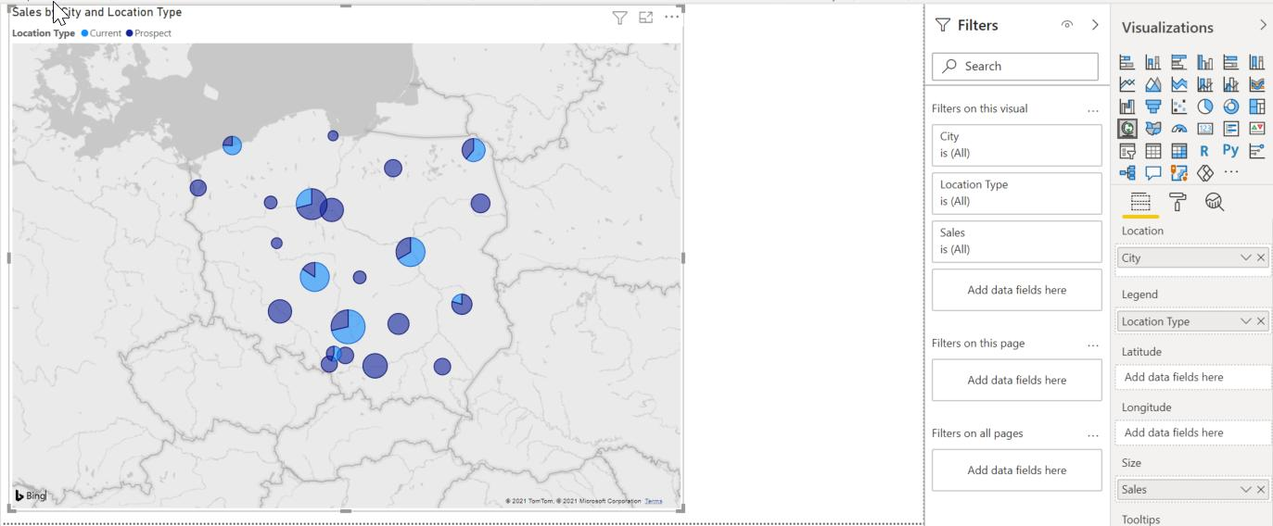
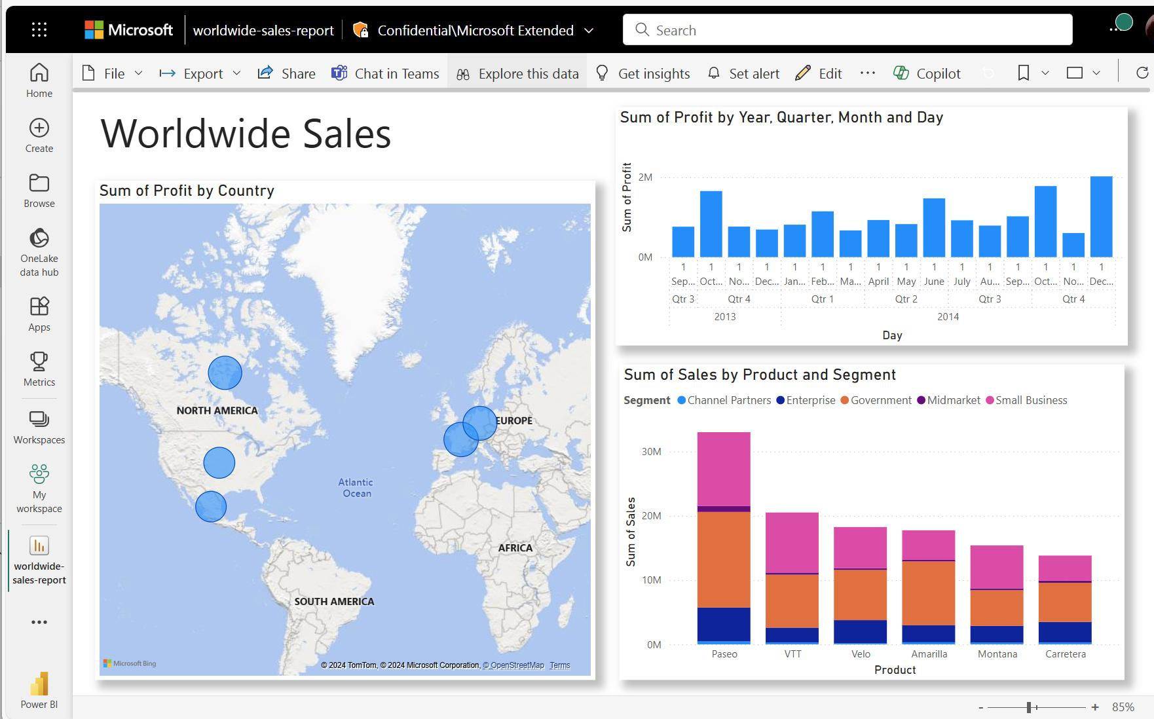
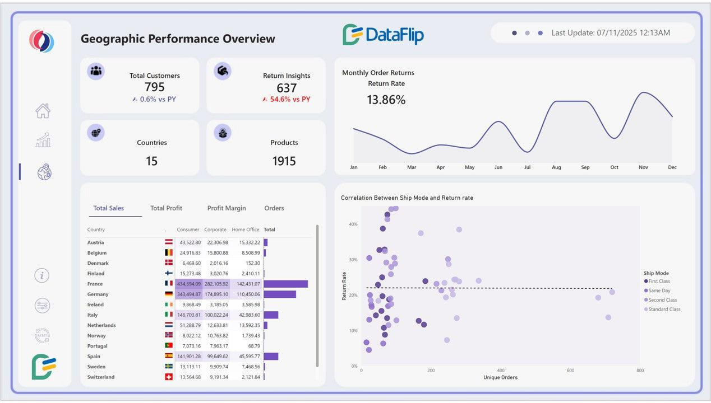

5. Bar Chart – Sum of Total Amount by Delivery Status
Categories Included
- Delivered
- Cancelled
- Returned
Purpose
Analyzes revenue based on delivery outcomes.
Analysis Performed
- Delivery success rate
- Cancelled orders
- Returned products
Business Use
- Measures delivery efficiency
- Monitors customer satisfaction
- Identifies operational issues

5. Key Insights Identified
The dashboard provided several important business insights:
- High-spending customers contributed significantly to total revenue.
- UPI and Card payments were widely used payment methods.
- Certain product categories generated higher sales than others.
- Most orders were successfully delivered.
- High-profit transactions contributed significantly to overall business performance.
- Geographic analysis helped identify regions with strong customer demand.

Tools Used
- Microsoft Power BI
- Microsoft Excel
- Data Transformation
- Data Visualization
- Business Intelligence
- Dashboard Design

Learning Outcome
On Day 22, I learned how to perform data transformation and business analysis using Microsoft Power BI.
I understood:
- how to create conditional columns
- how to classify profit categories
- how to segment customers based on spending
- how to create interactive dashboard visualizations
- how business dashboards support decision-making
- how to analyze sales, payment methods, and delivery performance

Conclusion
The E-Commerce Sales Analysis Dashboard successfully analyzed sales performance, customer behavior, payment trends, and delivery efficiency using interactive Power BI visualizations.
By applying data transformation techniques such as Profit Category, Order Priority, and Customer Segmentation, the dataset became more meaningful for business analysis. The dashboard provided valuable insights into customer spending patterns, product performance, and geographical sales distribution, helping support data-driven business decisions.

